DAA LAB ASSIGNMENT – 4
Course: Design and Analysis of Algorithms (DAA)
Student Name: Lavanyadevi K
Register Number: CH.SC.U4CSE24226
Department / Class: B.Tech CSE – Section C (2nd Year)

Q1. Prim’s Algorithm

Question
Write a C program to find the Minimum Spanning Tree (MST) of a given connected graph using Prim’s Algorithm.

Algorithm / Logic
- Read the number of vertices n.
- Read the cost adjacency matrix of the graph.
- Replace all 0 values (except diagonal) with a large value (∞) to indicate no direct edge.
- Select an arbitrary starting vertex and mark it as visited.
- Repeat until n−1 edges are selected:
  - Find the minimum cost edge connecting a visited vertex to an unvisited vertex.
  - Include this edge in the MST.
  - Mark the newly added vertex as visited.
- Calculate and display the total cost of the MST.

C Program
#include <stdio.h>
#define INF 999

int main() {
int n;
int cost[10][10], visited[10] = {0};
int i, j, count = 1;
int min, u = 0, v = 0;
int totalCost = 0;

printf("Enter number of vertices: ");
scanf("%d", &n);

printf("Enter cost adjacency matrix (0 for no edge):\n");
for(i = 0; i < n; i++) {
for(j = 0; j < n; j++) {
scanf("%d", &cost[i][j]);
if(cost[i][j] == 0)
cost[i][j] = INF;
}
}

visited[0] = 1;

printf("Edges in the Minimum Spanning Tree:\n");

while(count < n) {
min = INF;
for(i = 0; i < n; i++) {
if(visited[i]) {
for(j = 0; j < n; j++) {
if(!visited[j] && cost[i][j] < min) {
min = cost[i][j];
u = i;
v = j;
}
}
}
}

printf("%d - %d : %d\n", u, v, min);
totalCost += min;
visited[v] = 1;
count++;
}

printf("Total cost of MST = %d\n", totalCost);
return 0;
}

Output

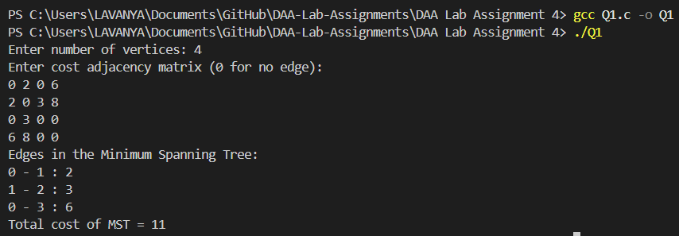

Interpretation
Prim’s algorithm constructs the Minimum Spanning Tree by always selecting the least-cost edge that connects a visited vertex to an unvisited vertex. By expanding the tree step by step, it ensures that the total cost of connecting all vertices is minimized.

Q2. Kruskal’s Algorithm

Question
Write a C program to find the Minimum Spanning Tree (MST) of a given graph using Kruskal’s Algorithm.

Algorithm / Logic
- Read the number of vertices n.
- Read the cost adjacency matrix of the graph.
- Replace all 0 values (except diagonal) with a large value (∞).
- Sort all edges in increasing order of their weights.
- Select the smallest edge and check whether it forms a cycle.
- If it does not form a cycle, include the edge in the MST.
- Repeat until n−1 edges are selected.
- Calculate and display the total cost of the MST.
C Program
#include <stdio.h>

int parent[10];

int find(int i) {
while(parent[i])
i = parent[i];
return i;
}

int uni(int i, int j) {
if(i != j) {
parent[j] = i;
return 1;
}
return 0;
}

int main() {
int n;
int cost[10][10];
int i, j;
int a, b, u, v;
int min, edges = 1;
int totalCost = 0;

printf("Enter number of vertices: ");
scanf("%d", &n);

printf("Enter cost adjacency matrix (0 for no edge):\n");
for(i = 0; i < n; i++) {
for(j = 0; j < n; j++) {
scanf("%d", &cost[i][j]);
if(cost[i][j] == 0)
cost[i][j] = 999;
}
}

printf("Edges in the Minimum Spanning Tree:\n");

while(edges < n) {
min = 999;
for(i = 0; i < n; i++) {
for(j = 0; j < n; j++) {
if(cost[i][j] < min) {
min = cost[i][j];
a = u = i;
b = v = j;
}
}
}

u = find(u);
v = find(v);

if(uni(u, v)) {
printf("%d - %d : %d\n", a, b, min);
totalCost += min;
edges++;
}

cost[a][b] = cost[b][a] = 999;
}

printf("Total cost of MST = %d\n", totalCost);
return 0;
}

Output

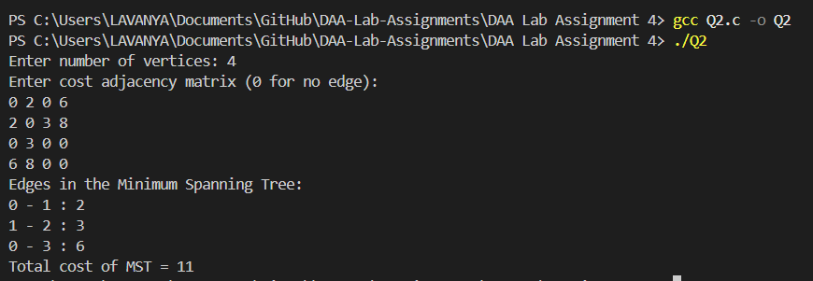

Interpretation
Kruskal’s algorithm constructs the Minimum Spanning Tree by selecting edges in increasing order of their weights while avoiding cycles. It ensures minimal total cost by always choosing the smallest available edge that does not form a loop.

